DevOps Engineer Assignment | Paytm Insider

Created Kubernetes manifest to expose a nodejs server with the following config:

* Auto scale at average 50% cpu and 60% memory.
* With 10 replicas running
* Used custom docker image hosted on GCP container register called bonomat/nodejs-hello-world:latest (any region).
* Created a service to expose the app on port 3000 via a classic load balancer.
* Any change to the deployment always ensures at least 7 replicas are running at all times.

Output after running the manifest files:

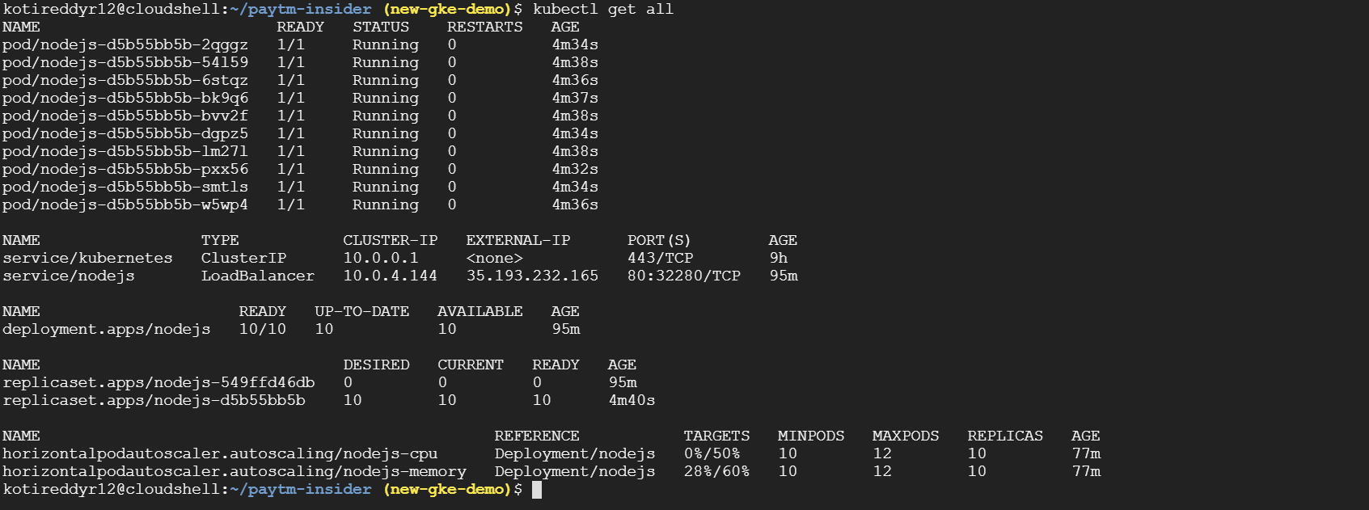

Tested the created service with external load balancer Ip:

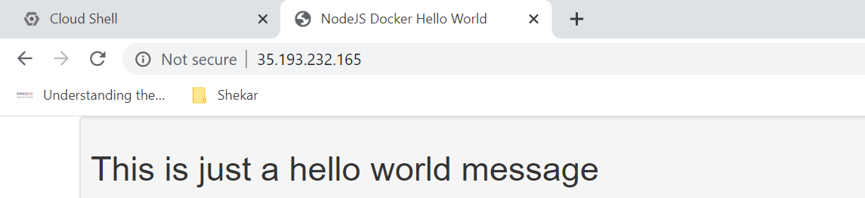

Performed the load test:



After load test replicas increased to 12:

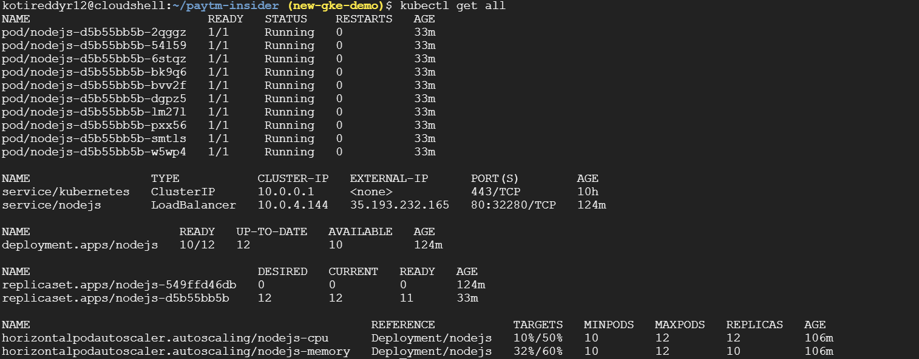

Results after reducing the load:

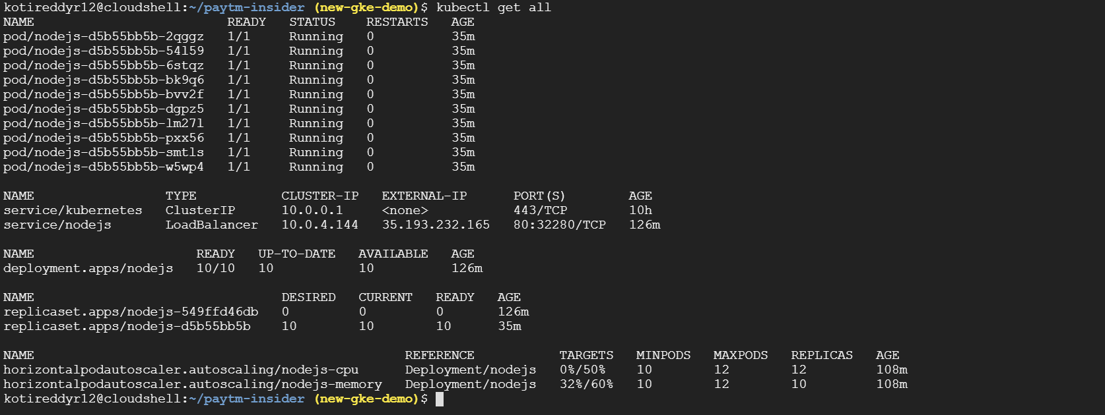

Cpu & Memory metrics during load test:

When load is high:

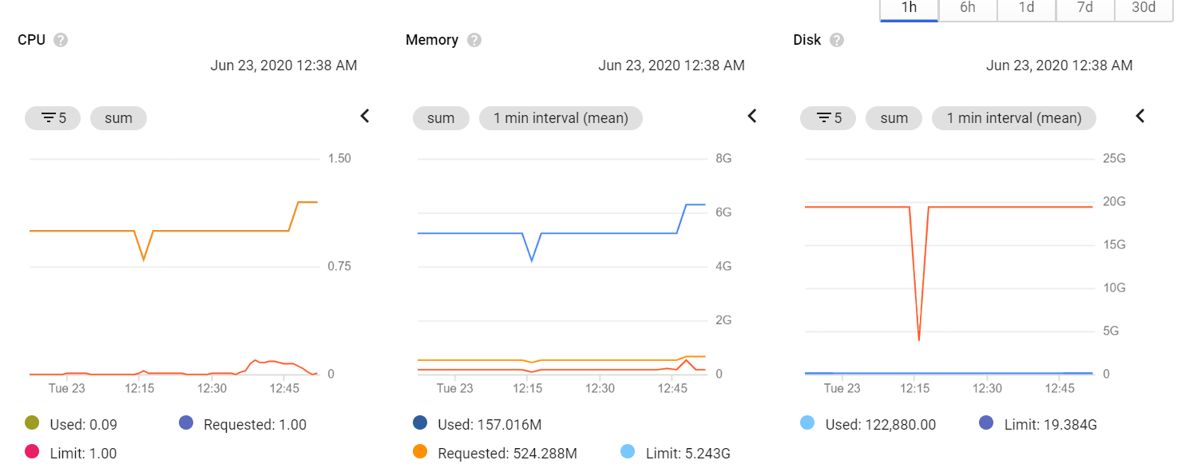

When load is reduced:

